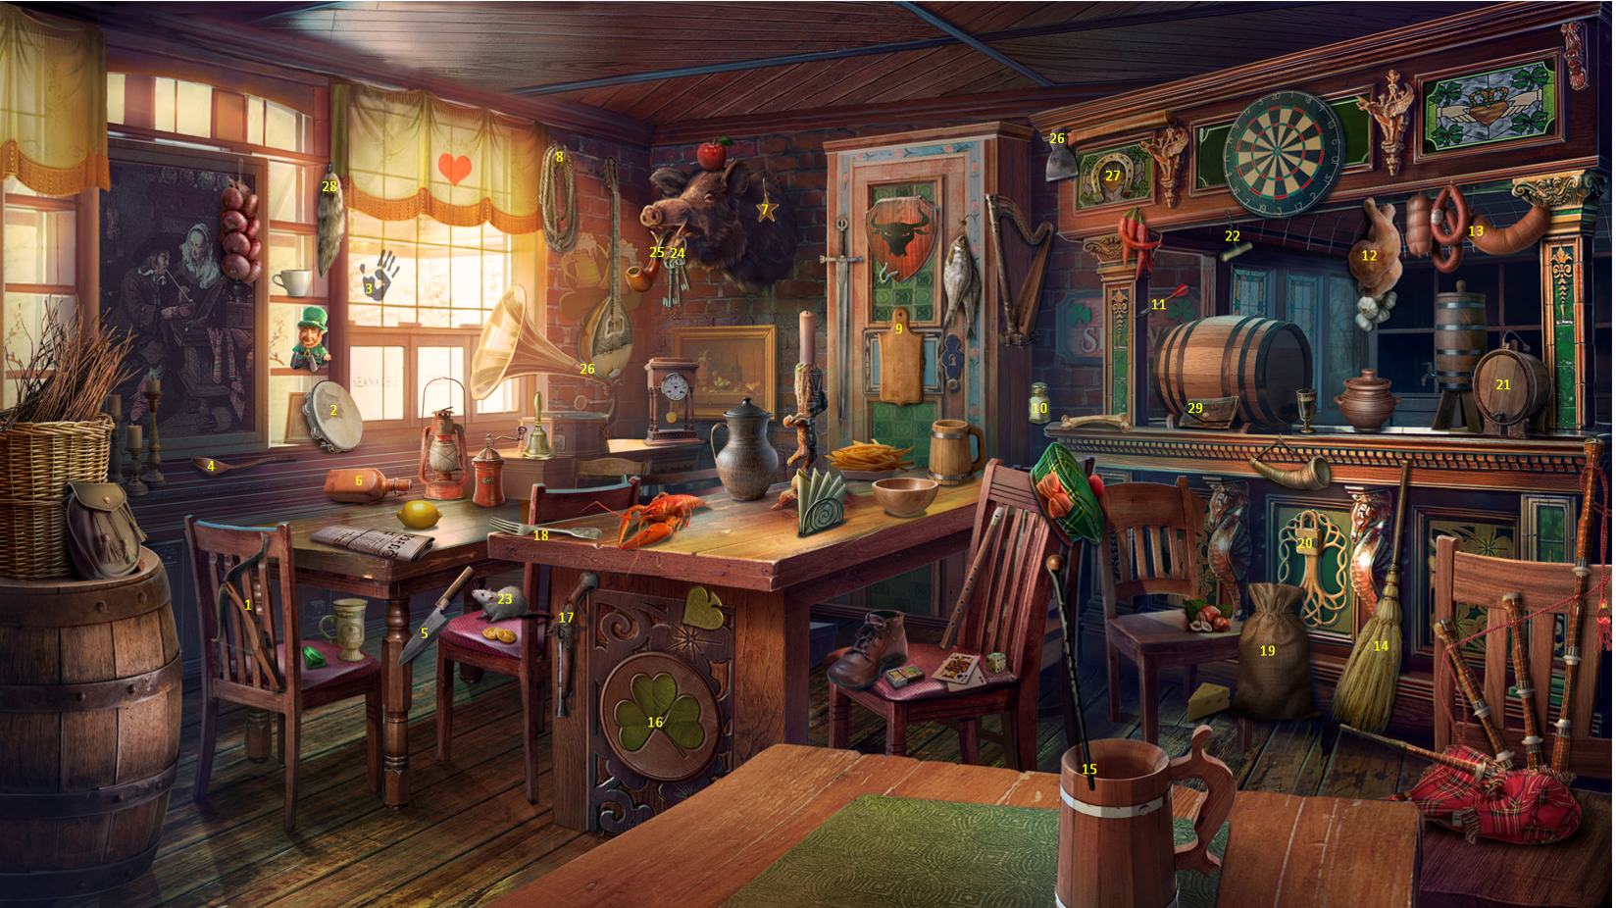

1. It is impossible to locate the points of attachment of the crossbow to the chair
2. The tambourine leaning on the picture is set unnaturally
3. The handprint does not look natural against the background of the whole picture
4. A spoon on two sides cannot lie so flat
5. The knife is hanging in the table leg, not stuck in it
6. The bottle is on the edge of the window sill and on the table at the same time
7. It is unclear how the star is attached to the fur of the boar's head
8. No rope attachment
9. The cutting board is not attached to the wall in any way
10. The bulk container is suspended in the air
11. The dart dart is not fixed in the rack design
12. There is no attachment to hang the "okorochka"
13. No fastener to hang the sausage products
14. The broom being in the foreground overlaps the musical instrument that is in the foreground
15. The image of a long thin tube is superimposed on the image of a wooden mug
16. The four-leaf clover is usually displayed with four leaves
17. No gun mount to the table
18. The fork is at an angle on the table, in this position it would lie parallel to the table
19. The bag in the background overlaps the chair in the foreground
20. No attachment for padlock
21. The distance from the rack of the structure to the tabletop does not allow you to place a barrel of this size on it.
22. The corkscrew is screwed on at the wrong angle
23. The rat in the background covers the back of the chair
24. The keychain is not hooked on the boar's mouth tusk
25. The pipe for smoking tobacco is not fixed in the boar's mouth
26. No mounts for axe installation
27. A horseshoe as a symbol of happiness is usually placed with the ends up, so that happiness "does not pour out.
28. There is no attachment for a fur-like product
29. The product looks like a leather purse is set up unrealistically.